Assessment of Arsenic Contamination of Groundwater and Health Problems in Bangladesh

Md. Khalequzzaman^{1*}, Fazlay S. Faruque², and Amal K. Mitra³

¹Department of Geology & Physics, Lock Haven University, Lock Haven, PA 17745, USA
²Office of Research, University of Mississippi Medical Center, 2500 North State Street, Jackson, MS 39216, USA
³Department of Community Health Sciences, University of Southern Mississippi, Box 5122, Hattiesburg, MS 39406, USA
*Correspondence to Dr. Md. Khalequzzaman. Email: mkhalequ@lhup.edu

Received: 10 January 2005 / Accepted: 10 April 2005 / Published: 14 August 2005

Abstract: Excessive amounts of arsenic (As) in the groundwater in Bangladesh and neighboring states in India are a major public health problem. About 30% of the private wells in Bangladesh exhibit high concentrations of arsenic. Over half the country, 269 out of 464 administrative units, is affected. Similar problems exist in many other parts of the world, including the Unites States. This paper presents an assessment of the health hazards caused by arsenic contamination in the drinking water in Bangladesh. Four competing hypotheses, each addressing the sources, reaction mechanisms, pathways, and sinks of arsenic in groundwater, were analyzed in the context of the geologic history and land-use practices in the Bengal Basin. None of the hypotheses alone can explain the observed variability in arsenic concentration in time and space; each appears to have some validity on a local scale. Thus, it is likely that several bio-geochemical processes are active among the region’s various geologic environments, and that each contributes to the mobilization and release of arsenic. Additional research efforts will be needed to understand the relationships between underlying biogeochemical factors and the mechanisms for arsenic release in various geologic settings.
Key words: Arsenic, Bangladesh, bio-geochemical processes, groundwater, health problems.

Introduction

Arsenic is a natural component of the Earth's crust. It can be found in soil and water that have interacted with arsenic-rich rocks. Arsenic can also be introduced into the groundwater anthropogenically through the application of the arsenic-rich herbicides and pesticides that are frequently used on agricultural lands.
The maximum acceptable levels of dissolved arsenic in drinking water is 0.01mg/l and 0.05mg/l according to the World Health Organization and the United States Environmental Protection Agency, respectively [1, 2]. Acceptable levels of dissolved arsenic in drinking water in Bangladesh are 0.05 mg/l. Drinking water that has elevated levels of arsenic for a prolonged time period is unsafe, and specific health risks are well documented [3, 4].
Arsenic-contaminated groundwater was first documented in groundwater in 1984 [4]. Since then, several systematic studies have been carried out to
determine the extent and severity of this contamination [5, 6]. The magnitude of the problem is not yet known, however, the number of affected tube wells and arsenic-related health complaints is on the rise. About 30% of 10 million private wells are highly contaminated. Most people in Bangladesh use groundwater water as a source of drinking water because the surface water has unacceptable level of bacterial contamination. A total of 269 out of Bangladesh’s 464 administrative units, called upazilla, more than half the country, contain high levels of arsenic-contaminated drinking water (Fig. 1).
In addition to Bangladesh, several countries in the world have identified excess amount arsenic in drinking water including Argentina, Bangladesh, Chile, China, Hungary, India, Japan, Mexico, Mongolia, Poland, Taiwan, and the United States. However, it is noteworthy that the number of people affected by arsenic pollution in Bangladesh exceeds the total number of people affected by arsenic pollution in all other countries combined.

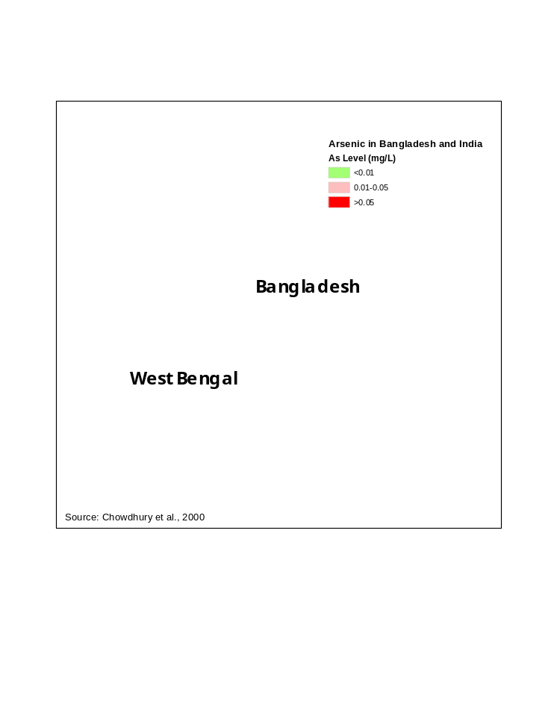

Figure 1: Arsenic concentrations in groundwater in Bangladesh and West Bengal, India [4].

Geology of Bangladesh in Relation to Arsenic in Groundwater

Most of Bangladesh and West Bengal, India, fall within the Bengal Basin, one of the world’s largest geosynclinal troughs (a large elongate or basin-like structure on Earth’s surface). The Ganges-Brahmaputra-Meghna river system occupies this extensive basin. As it nears the Bay of Bengal coast, this system spreads out forming many distibutary channels. Along the coast, the mean tidal range is high, and wave energy is low. As a result, the Ganges-Brahmaputra deltaic complex serves as a textbook model of a tide-dominated delta.
The Bengal Basin comprises a wide variety of fluvial (e.g., channels, floodplains, natural levees, back swamps) and marginal marine (e.g., distributary channels, mangrove forests, tidal flats, beaches) sedimentary environments. Distinctive sediment, biological activity, and chemical and physical processes characterize each of these environments. They inter finger laterally as well as vertically and continuously change their position in response to tectonic disturbances as well as global variations in climate and sea-level fluctuations.
Although sea level has varied considerably throughout geologic time, the changes over the last 1.6 million years (Pleistocene and Holocene epochs) have been dramatic. During this time, the sedimentary environments of the Bengal Basin shifted both seaward and landward relative to the present coastline in response to global sea-level changes. It is likely that the southern boundaries of the Pleistocene highlands, terraces such as the Barind Tract, Madhupur Tract, and Tippera Terrace, marked the position of the paleo-shoreline (shoreline position at a given time in the past) during the last interglacial period (125,000 years ago).
As sea level fell to its lowest stand during the last glacial maximum (~18,000 years ago), the shoreline gradually advanced ocean-ward (to the south). Since then, the shoreline migrated landward as sea level rose. Sea level in the Bay of Bengal was about 7 m below its present position about 7000 years ago [9]. As a consequence, the various depositional environments migrated back and forth between the Pleistocene highlands and the position of the present shoreline, leaving behind their characteristic sedimentary features, now buried beneath the recent sedimentary cover. For example, the gradient of rivers must have been higher during the low sea stand, facilitating formation of incised river valleys. Lower parts of these incised river valleys must have been filled with fine-grained and organic-rich sediments during subsequent sea-level rise. It is important to analyze the spatial relationship between these valley fills and high concentration of arsenic in underlying aquifers.
Arsenic concentration data throughout the basin are highly variable on both spatial (map view; refer to Figure 2) and temporal (at depth in cross sections and drill holes) scales. The reason for this variability is not well-understood. The source of arsenic in this region is dependent on the geology of the upstream region and land-use practices in the catchment’s areas of the major rivers that carry and distribute the sediment and anthropogenic waste materials.

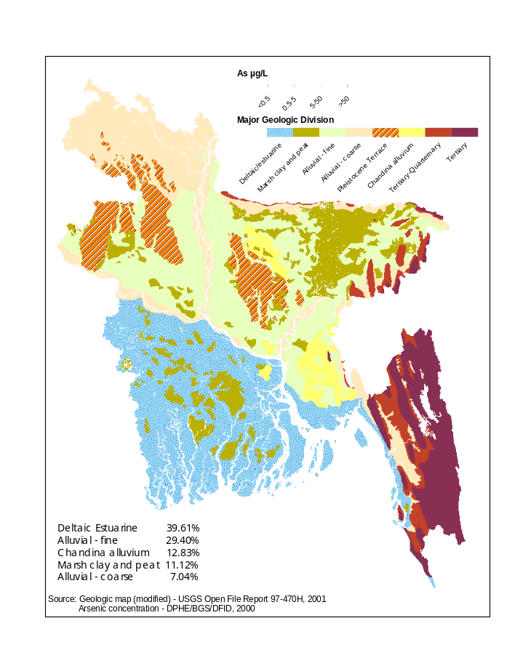

Figure 2: Geologic units and arsenic concentrations in groundwater in Bangladesh [7, 8].

However, the geological, hydro geological and bio-geochemical processes operating during sediment deposition played a significant role in controlling the mobility of arsenic. Dissolved arsenic exists as several chemical species, the stability of which depends on the oxidation-reduction potential of the environment, as well as the microbial activity present at various depths in the sedimentary deposits [10]. The amount of dissolved organic content and dissolved ions likely to play a role in
arsenic mobility. For example, arsenic-bearing iron can form chemical complexes with other anions, which, in turn, can enhance the solubility and mobility of arsenic species. The degree of complexation of arsenic-bearing iron cations is likely to be a higher in groundwater that has high concentration of dissolved organics and other anions, such as the groundwater found at mid-depth aquifers in Bengal Basin [5-7]. In order to better understand the complexity of the origin, pathways, and sinks of dissolved arsenic in groundwater, a detailed analysis of subsurface geologic history and bio-geochemical processes is necessary. Constructing paleogeographic (distribution of land and water at a given time in the past) maps of the Bengal Basin based on the depositional environments at depth can aid in the interpretation of the data and suggest mechanisms responsible for the mobility of the dissolved arsenic.
Figure 3 shows the regional tectonic map (portrayal of large geologic structures on Earth’s surface). The distribution of high arsenic concentrations appears to have a strong correlation with certain tectonic elements in Bangladesh. For instance, over 75% of tubewells contaminated with high arsenic concentrations are found in Bengal Foredeep (low-lying elongated depression) area, which consists of Faridpur Trough, Barisal Gravity High, Hatiya Trough, and Sylhet Trough.

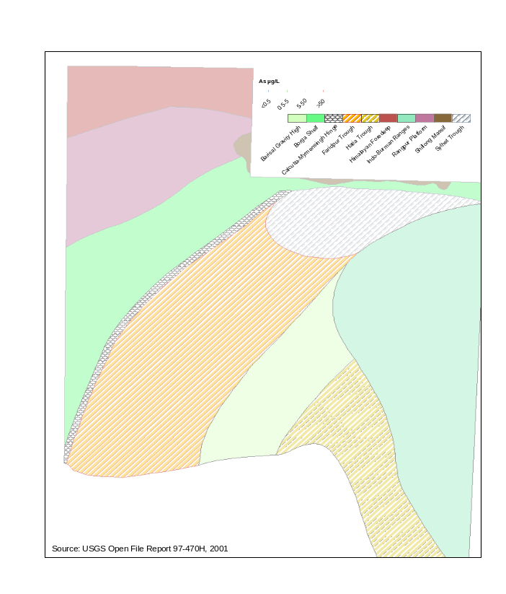

Figure 3: Map showing the distribution of arsenic in the context of the generalized tectonic map of Bangladesh [7, 8].

Origin and Mechanism of Arsenic Mobilization

Four hypotheses are proposed to account for the origin and mechanism of the arsenic pollution (i.e. an amount sufficient to cause health problems) of groundwater in Bangladesh. The proposed mechanisms are as follows:
- Oxidation of arsenical pyrite;
- Reductive dissolution of FeOOH (hydrous ferric oxides or HFO) resulting in the release of sediment-bound arsenic;
- Anion (competitive) exchange of sediment-bound arsenic with phosphate from fertilizers;
- Release of arsenic from the degradation of pesticides* and fertilizers. We used published data as well as the knowledge of socio-environmental and geologic conditions in Bangladesh in critically reviewing these mechanisms to explain arsenic release to groundwater.

Oxidation of Arsenical

According to this hypothesis, the arsenic pollution results from oxidation of authigenic pyrite that is concentrated in deposits of organic matter due to lowering of the water table. This hypothesis implies that arsenical pyrite oxidizes in the vadose zone (drawdown zone around pumping wells) releasing arsenic attached on iron hydroxides [11, 12, 13]. The proponents of this hypothesis also suggest that increased drawdown during the dry season and the subsequent recharge of groundwater facilitates this oxidation process. They argue that the arsenic pollution is a recent phenomenon, which is triggered by the diversion of surface water in upstream regions of the Ganges River. The following chemical reaction is proposed as a mechanism for the release of arsenic from arsenical pyrite [10]:

FeS₂-As(s) + 7/2 O₂ +H₂O = Fe₂⁺ + 2SO₄²⁻ + 2H⁺ + As(aq)

Questions addressing this mechanism include:

- Why is arsenic found in areas that are not affected by upstream diversion of surface water, such as in the Meghna basin (NE Bangladesh)?
- Why are arsenic concentrations not highest in the unsaturated zone beneath the surface where the groundwater table fluctuates between dry and wet seasons?
- Does arsenic pollution increase during the wet season?
- Are the Eh-pH field changes in the aquifer due to drawdown?
- Why is the arsenic pollution so severe in West Bengal and Bihar where upstream diversion of surface water did not occur?
- Why does the arsenic pollution occur in areas where drawdown is not a likely cause for oxidation, such as in Wisconsin, USA?

Reductive Dissolution of Hydrous Ferric Oxides (HFO).

According to this hypothesis, arsenic contamination results from microbial reduction of organic-rich, fine-grained sediments that contain arsenic-coated hydrous ferric oxides (HFO) which were deposited in low-lying floodplains and coastal plains during the last several thousand years [6, 14-19]. This hypothesis implies that arsenic is released from HFO surface when iron-reducing bacteria oxidize organic carbon for their metabolism. The following chemical reaction is proposed as a mechanism for arsenic release from HFO [6]:

8FeOOH + CH₃COO⁻ + 15H₂CO₃ → 8Fe²⁺ + 17HCO₃⁻ + 12H₂O

If this is true, then arsenic would be found in groundwater that passes through organic rich sediments. However, arsenic concentration, though most common in shallow aquifers at depths ranging from 15 to 75 meters (m) in low-lying (i.e. elevation less than 10 m) coastal plain regions (i.e. Faridpur Trough, Hatiya Trough, and Barisal Gravity High in Fig. 3), is not exclusive to this geologic setting and depth range. For instance, high concentrations of arsenic are also found in Sylhet Trough, Bangladesh (Fig. 3), Bihar and Chattishgarh, India, and Nepal, which do not represent low-lying floodplain or coastal plain settings. Moreover, the sea level has risen about 7 m over the last 7,000 years [9], however the high concentration of arsenic is not limited to aquifers that were deposited during last several thousand years. Aquifers that are deeper than 100 m and are separated from the shallow aquifers also contain high concentrations of arsenic.
Additionally, the following questions relative to this hypothesis demand answers:
- Is there a peat layer above the aquifer in the entire area that is polluted with arsenic?
- Even if peat layers and/or organic rich sediments occur in aquifer materials, at what depth do they occur?
- Why is there arsenic pollution along the Brahmaputra riverbanks, where sediments are predominantly sandy in nature?
- The peat layer associated with the low sea level position in the Bengal Basin is found at depths ranging from 2 to 7 m below mean sea level and about 80 to 120 km landward of the present shoreline location. Why then is the aquifer located at depths ranging from 15 to 75 m polluted with arsenic? How does the arsenic produced in the peat layer located at 2 to 7 m move to a greater depth?
- If organic-rich sediments are deposited in tidal flat or coastal plain environments, why are there no high concentrations of arsenic in most of today’s coastal plain, such as in Bhola, Barguna, and Patuakhali (south central parts in Figures 2 and 3)
- The Madhupur Tract and Barind Tract are also very similar in their geologic origin, i.e. they represent ancient delta plain and floodplains. Why are there no organic-rich sediments and high concentrations of arsenic in the aquifers in those areas?
- Can the hypothesis account for the variability in arsenic concentrations in terms of time-dependent field data? [20].

Competitive ion Exchange

Depending on the redox potential and acidity of the environment, arsenic can exist in several anionic forms. Arsenic is attached on surfaces of fine-grained clay and hydrous ferric oxides. When other anions, such as phosphates (from fertilizers and other sources), exist in excess, they can replace arsenic anions and release the arsenic to groundwater. Phosphate anions are relatively immobile and get attached to mineral grains near the surface. Accordingly, the “overuse” of phosphate fertilizers during the last few decades must have played a role in dislodging arsenic attached to mineral grains and introducing it into groundwater [21].
The competitive ion-exchange mechanism, however, would not be very effective in deeper aquifers. Arsenic concentrations appear to be highest at depths ranging from 15 to 75m. These are not explained by this hypothesis. Additionally, fertilizer usage is very common in all parts of Bangladesh. It follows that if phosphate anions from fertilizers were responsible for the release of arsenic to the groundwater, then arsenic would be present in groundwater throughout Bangladesh; however, arsenic concentrations do not follow this pattern (Figures 2 and 3). Also, over 75% of the high concentrations of arsenic are found in fine-grained, organic rich (marsh clay and peat) sediments (alluvial/deltaic silt and clay) in tidal and deltaic environments, a fact that cannot be explained by this hypothesis.
Relative to this hypothesis, the questions that beg answers are as follows:
- Why do not the phosphate anions from fertilizers force the release of arsenic in all geologic settings equally?
- Why are arsenic concentrations not high in surface water where phosphate anions are supposed to be in high concentration?
- Is there any relationship between fertilizer application and elevated arsenic concentrations in Bangladesh or elsewhere?

Release of Arsenic from Degradation of Pesticides and Fertilizers

Apparently, some of the chemical fertilizers and pesticides used in Bangladesh contain high amounts of arsenic, which might have been introduced into groundwater [22, 23]. According to this study [23], there is no evidence that arsenic originated from any natural source in Bangladesh. It is also claimed that a large amount of arsenic trioxide is kept in stock at Ghorasal Fertilizer Factory in Bangladesh for use or disposal to unknown destinations. About 30% of the fertilizers used in Bangladesh are lost through surface run-off. It is also suggested that in some parts of Bangladesh there is an apparent correlation between the amount of fertilizers used in crops and the amount of arsenic present in groundwater [23].
It has not been demonstrated that fertilizers and pesticides have been applied in sufficient quantities to degrade groundwater quality in Bangladesh [24]. Other questions relative to this hypothesis that need to be answered are as follows:
- What are the pathways and sinks of pesticides and fertilizers as they relate to groundwater movement?

Table 1: Summary of four competing hypotheses regarding the mechanism for arsenic occurrence and mobilization in groundwater in Bangladesh.

Hypotheses | Major Determining Factors | References | Major Unexplained Aspects
Oxidation of arsenical pyrite | -Requires pyrite as source of As  -Requires oxygen associated with lowering of groundwater table | [11, 13, 15] | -Known occurrence of As do not always correspond with oxidizing environments in aquifers  -Presence of pyrite in all polluted aquifers is not documented  -Presence of As in areas not affected by groundwater withdrawal (e.g. Nepal, Bihar and Chattishgarh, India )  -As is also present in geologic settings that are different from those in Bangladesh  -Not supported by data collected from aquifers at different depths and geologic environments  -Not demonstrated to work with hydro geochemical modelling at large scales  -Pyrite is not stable in the known oxidation-reduction-potentials of aquifers in Bangladesh
Reductive dissolution of hydrous iron oxides (HFO) | -Results from microbial reduction  -Requires presence of organic-rich sediments in aquifers  -Requires reducing environment in aquifers containing HFO  -As release mechanism must have been present over geologic time | [6, 19] | -Known occurrence of As does not always correspond to known presence of organic-rich layers  -Oxidation-reduction potential of aquifer is not always reducing where As has been reported  -As also present in geologic settings other than coastal/delta plain (e.g. in northern areas of Bangladesh, India, and Nepal)  -Not supported by data collected from aquifers at different depths and geologic environments  -As contamination appears to be a relatively recent phenomenon  -Not demonstrated to work with hydrogeochemical modelling at large scales
Competitive ion exchange | -Requires high concentrations of phosphates in groundwater | [21] | -Amount of phosphate anions available from fertilizers do not correspond with the calculated amount of As present in groundwater  -High concentrations of phosphates are not demonstrated where As is found  -No relationships between fertilizer applications and As occurrence has been established  -Phosphate is immobile and is not common in groundwater (15-75m) where As is found
Arsenic from pesticides and fertilizers | Requires application of adequate amount of arsenic-bearing pesticides & fertilizers | [22, 23] | -Amount of reported As in groundwater cannot be accounted for by the amount of potential arsenic released from cumulative use of fertilizers and pesticides  -Pesticide and fertilizers are applied most everywhere in Bangladesh, but the high As concentration does not match the pesticides/fertilizer application patterns

How do the pesticides and phosphate fertilizers move through the fine grained sediments into the deep aquifers?
- Why is the amount of arsenic in groundwater not proportional to the amount of pesticides and fertilizers used Bangladesh?
- Are there any seasonal variations in the amount of arsenic observed in groundwater that reflects the usage of pesticides and fertilizers?
- Why are the high concentrations of arsenic predominantly associated with the low-lying coastal/deltaic environments that are characterized by fine-grained sediments (Fig. 2)?

Unsolved Geologic Problem and Its Consequences on Human Health

The lack of understanding of the origin, pathways, and sinks for arsenic contamination in Bangladesh’s groundwater is taking a terrible toll on human health. The arsenic contamination has reached an epidemic proportion. Millions of people are suffering from various arsenic-related diseases, and millions more are exposed to the possibility of contacting these diseases. Arsenic is also finding its way into the food chain. In order to better understand the affect that arsenic has on human health and the state of the epidemic in Bangladesh, it is imperative that the link between the food and arsenic uptake by people in Bangladesh be examined thoroughly before any remedial actions can be taken to mitigate this problem. To illustrate the nature and severity of arsenic-related diseases, in the next section entitled “Effect of Arsenic Poisoning on Health”, we have included the results of an investigation that one of the authors (Mitra) carried out with other researchers [36].

Effect of Arsenic Poisoning on Health

Chronic arsenic poisoning, arsenicosis, can increase the risk of several health hazards including skin lesions, cancers, restrictive pulmonary disease, peripheral vascular disease (blackfoot disease), gangrene, hypertension, non-cirrhotic portal fibrosis, ischemic heart disease, and diabetes mellitus [25-35]. A study of 150 patients (75 males and females) visiting the dermatology outpatient department of the Sher-e-Bangla Medical College Hospital, Barisal district, Bangladesh, in 2000, provides substantial evidence for this link. In addition, results confirm the connection between arsenic toxicity and malnutrition.

Skin Lesions

Skin changes due to arsenic poisoning include a raindrop pattern of pigmentation and depigmentation that is particularly pronounced on the extremities and the trunk. Although less common, other patterns include diffuse hyperpigmentation (melanosis) and localized or patchy pigmentation, particularly on skin folds. Hyperkeratosis (hardened skin) appears predominantly on the palms and the planter surface of the feet. In the early stages, the involved skin might have an indurated, gritlike character that can be best appreciated by palpation; however, the lesions usually advance to form raised, punctuated, 2-4 mm wart-like keratosis that are readily visible. Occasional lesions might be larger (0.5 to 1 cm) and have a nodular or horny appearance occurring in the palm or dorsum of the feet. In severe cases, the hands and soles display diffuse verrucous lesions [26]. All the patients of our study displayed raindrop skin pigmentation, and more than 80% had hyperkeratosis with or without nodular skin lesions (Fig. 4). One hundred and twenty-three (82%) patients had moderate or severe skin lesions. Sites of the skin lesions were trunk, including chest (38%), hands only (18%), both hands and feet (15%), feet only (13%), and chest only (11%).

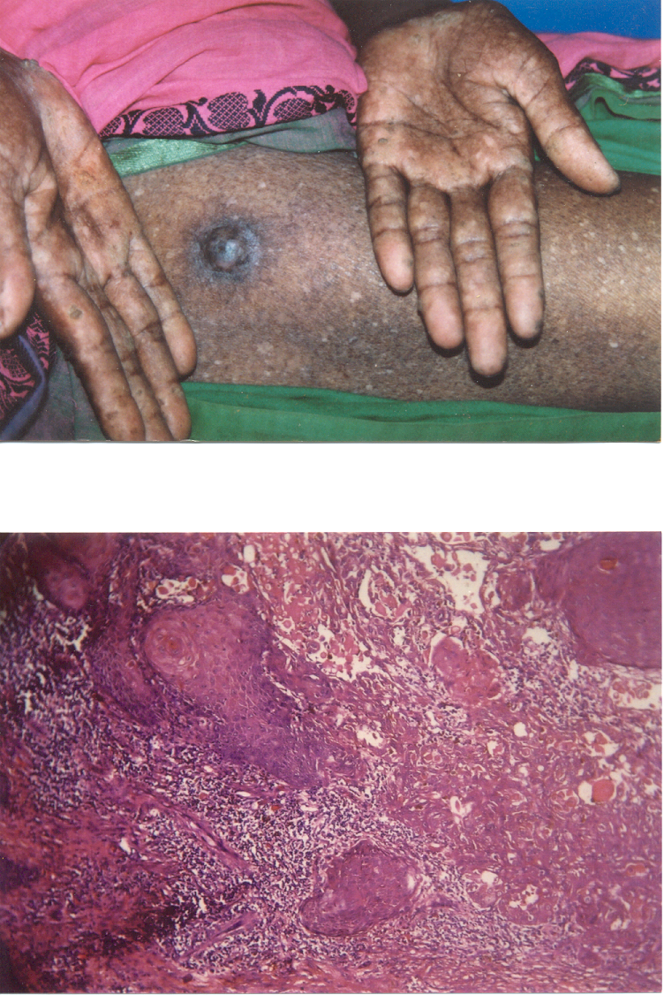

Figure 4: A 42-year old woman having characteristic raindrop skin lesions on her both extremities and a nodule on her thigh [36].

Skin Cancer

Skin cancer resulting from chronic arsenicosis is quite distinctive. Multiple lesions are common and involve covered areas of the body, contrary to non-arsenical skin cancers which usually appear as a single lesion and which occur in exposed parts of the body. In our study, biopsy specimens from skin nodules of one person, aged 42 years, showed squamous cell carcinoma (Fig. 5). Other types of cancers reported in significantly higher number among patients with chronic arsenic poisoning include cancers of lung, urinary bladder, kidney, prostate, and liver.

Figure 5: Biopsy specimen from the nodule showed anaplastic squamous epithelial cells in interconnected sheets and islands in the dermis. Well-defined keratin horn pearls are also demonstrated (Hematoxylin-Eosin Stain, x122) [36].
Clinical Symptoms and Findings

About 18% of our study patients did not complain of any clinical symptoms, except that their skin lesions were ugly-looking. One hundred and fifteen (77%) subjects had multiple symptoms, including weakness, chronic cough, joint pain, itching, abdominal pain, chest pain, loss of appetite, insomnia, shortness of breath, and frequent urination with burning (Table 2).

Table 2: Ranking of clinical symptoms of arsenic-related illnesses in 150 patients admitted to the Sher-e-Bangla Medical College Hospital, Barisal, Bangladesh, January-December 2000.
Clinical features | Number (%)*
Weakness | 59 (39)
Chronic cough | 35 (23)
Joint pain or backache | 26 (17)
Itching | 26 (17)
Abdominal pain | 24 (16)
Chest pain | 24 (16)
Loss of appetite | 18 (12)
Insomnia | 15 (10)
Shortness of breath | 15 (10)
Frequent urination with burning | 15 (10)
Tingling and numbness | 12 (8)
Headache | 12 (8)
Malaise | 8 (5)
Chronic dysentery | 6 (4)
Blurred vision | 4 (3)
Conjunctivitis | 2 (1)
Palpitation | 2 (1)
Deceased libido | 1 (1)
*Total percentage exceeds 100 because several patients had multiple symptoms and complications [36].

High blood pressure (systolic BP ≥ 140 mm Hg or diastolic BP ≥ 90 mm Hg) and depression (lowered mood or sadness, loss of interest, and anxiety) were the two most frequent complications, each observed in 20 (13%) of our study subjects. The other important findings included raised serum alanine aminotransferase (n = 13), palpable liver (n = 8), X-ray features suggestive of pneumonia, interstitial lung disease and lung abscess (n = 11), peripheral vascular problems in the form of intermittent claudication, in the absence of history of smoking (n = 2), pulmonary tuberculosis (n = 2), diabetes (n = 1), and decreased libido (n = 1). Anemia (hemoglobin: <135g/L in males, and <120g/L in females) was a major clinical finding observed in 88 (58%) subjects; 14 had pedal oedema. Ten (7%) patients were admitted to the hospital due to complications or associated major illnesses, including severe anemia, hepatitis, hepatic cirrhosis, renal failure, lung abscess, interstitial lung disease, intermittent claudication with uncontrolled diabetes, and skin cancer. One of them died due to heart failure from chronic obstructive pulmonary disease and lung abscess.
Several clinical symptoms that appeared in our subjects had conformity with previous reports [23-35, 37, 18]. A dose-effect relationship has been reported between arsenicosis and patients with skin cancer, blackfoot disease, cardiovascular disease, hypertension, and diabetes [25, 33, 34, 39]. We found a significant direct relationship between the mean arsenic concentration in water and the severity of the clinical disease.

Nutritional Status and Disease

Eighty-nine percent of our patients were underweight and 11% were weight-appropriate; none were overweight or obese. After controlling for age, the duration of disease varied inversely with BMI (r = -0.298, P = 0.013, n =70). Their body weight, height, and BMI did not differ by the severity of disease. Evidence suggests that poor nutritional status may increase toxicity to arsenic retained in the body, probably by diminished ability to methylate inorganic arsenic [40]. Patients with protein-energy malnutrition are particularly deficient in methionine. Studies by Vahter and Marafante found that a low amount of methionine or protein in the diet decreased methylation of inorganic arsenic in rabbits [41]. Deficiency of certain other dietary trace elements, including zinc and selenium, also associated with malnutrition, may contribute to the toxic effects of accumulated levels of arsenic in the body [42]. Our study confirmed previous reports of the relationship between malnutrition and increased arsenic toxicity [43]).

Arsenic Contaminating Vegetables and Crops

Generally, in unpolluted environments, ordinary crops do not accumulate enough arsenic to be toxic to man. However, in arsenic contaminated soil, the uptake of arsenic by the plant tissue is significantly elevated, particularly in vegetables and edible crops [44]. There is, therefore, concern regarding accumulation of arsenic in agricultural crops, vegetables, and fishes grown in the arsenic-affected areas of Bangladesh.
In a recent study of 100 samples of crop, vegetables and fresh water fish collected from three different regions in Bangladesh. Arsenic concentrations were not increased in samples of rice grain (Oryza sativa L.) [45]. The results of the study were consistent with a previous study in Bangladesh [46]. However, rice plants, especially the roots had a significantly higher concentration of arsenic (2.4 mg/kg) compared to stem (0.73 mg/kg) and rice grains (0.14 mg/kg). While not covered by food hygiene regulations, rice straw is used as cattle feed in many countries including Bangladesh. The high arsenic concentrations in straw may have the potential for adverse health effects on the cattle and an increase of arsenic exposure in humans via the plant-animal-human pathway. Further studies are needed to measure arsenic concentration in meat from cattle fed on contaminated rice straw.
In the study by Das et al. [45] it was found that arsenic contents of vegetables varied; those exceeding the food safety limits included Kachu sak (Colocasia antiquorum) (0.09 - 3.99mg/kg, n = 9), potatoes (Solanum tuberisum) (0.07 - 1.36 mg/kg, n = 5), and Kalmi sak (Ipomoea reptoms) (0.1 - 1.53mg/kg, n = 6). Lata fish (Ophicephalus punctatus) (n = 9) did not contain unacceptable levels of arsenic. These results indicate that arsenic contaminates some food items in Bangladesh. Further studies with larger samples are needed to demonstrate the extent of arsenic contamination of food in Bangladesh.
In addition to carrying out research to fully understand the health implications of arsenic contamination of groundwater and food sources, it is necessary to determine the sources, chemical behaviors, hydrogeologic control, and pathways of arsenic in groundwater in Bangladesh. As discussed above, there is no clear understanding of the geology and its relationships to arsenic contamination in Bangladesh. In the next section entitled “Future Research and Policy Implications” we have offered specific suggestions for policy makers and researchers who are involved in arsenic mitigation and remediation projects.

Conclusions

Based on critical review of the four competing hypotheses, we conclude that none of these hypotheses can solely explain the nature of variability of the arsenic concentration found in groundwater in Bangladesh. Additional research will be needed before any prediction can be made as to the occurrence, mobility, and concentration of arsenic in aquifers in different geologic settings. To this end, new directions for future research are suggested by the authors involving:
- A comprehensive study of the geologic history including the compilation of paleogeographic interpretations for various time intervals.
- The identification of the biogeochemical processes active in different geographic and geologic settings.
- The investigation of regional land-use practices.
- The design of appropriate conceptual models for determining groundwater flowpaths.
- The design of appropriate geochemical models of reaction mechanisms.
- A comprehensive study of the epidemiological aspects of the problem. These studies need to be undertaken in order to establish relationships between biogeochemical factors responsible for the release of arsenic and the observed concentrations of arsenic in groundwater in Bangladesh.

Future Research and Policy Implications

Our research analyzed four existing hypotheses addressing the arsenic problem in Bangladesh. We found that none of the hypotheses listed above solely can explain the nature of variability of the reported arsenic concentrations. Further studies are needed in the following areas:
- Detailed lithologic descriptions of well logs (types and characteristics of units) to establish a 3-D framework of the geologic strata to identify and characterize those units acting as aquifers (porous and permeable layers that hold and transmit water to tubewells) aquitards (impervious layers that impede water movement through them) in the arsenic-affected areas.
- The geologic history of evolution of the Bengal Basin and the resultant sediments as a function of time and space.
- Reconstruct paleogeographic maps of Bangladesh, which will illustrate the types of sediments deposited at various locations and depths at a given time period.
- Develop conceptual models of groundwater flowpaths, with evidence supported by computer simulations.
- Use geochemical data collected from the existing pumping wells, as well as from newly drilled wells, to develop geochemical models, which can be used to determine the types of chemical reactions and products, including possible chemical complexes. The best way to determine complexes is to utilize geochemical computer codes, such as MINTEQ or PHREEQE [47].
- Compile geologic information for sediments and chemicals observed at various depths to decipher spatial and temporal relationships between sediments and arsenic concentrations.
- Multidisciplinary studies to better understand biogeochemical environments and epidemiological relationships to the natural environments.
To combat the health problems due to arsenic poisoning, it is necessary to:
- Enhance public awareness of the health problems from contaminated water.
- Take short- and long-term intervention strategies to curb the exposure.
- Strengthen rapid diagnostic facilities.
- Establish effective treatment facilities in rural areas.
- Improve the nutritional status of the people.

References

- WHO. Guideline for Drinking Water Quality, Recommendation, Vol. 1. 2nd ed. Geneva: World Health Organization. 1992, 41.
- U.S. EPA. Drinking Water Regulations and Health Advisories. Washington, DC: U.S. Environmental Protection Agency, Health and Ecological Criteria Division. 1993.
- Saha, K. C.: Saha’s grading of arsenicosis progression and treatment. In: Arsenic Exposure and Health Effects V. Chappell, W. R.; Abernathy, C. O.; Calderon, R. I.; Thomas, D. J. (editors). Elsvier: Amsterdam, 2003, pp. 391-414.
- Chowdhury, U. K.; Biswas, B. K.; Chowdhury, T. R.; Samantha, G.; Mandal, B.; Basu, G. C.; Chanda, C. R.; Lodh, D.; Saha, K. C.; Mukherjee, S. K.; Roy, S.; Kabir, S.; Quamruzzaman, Q.; Chakrabarti, D. Groundwater arsenic contamination in Bangladesh and West Bengal, India. Environmental Health Perspectives, 2000, 108, 393-397.
- Frisbie, S. H.; Ortega, R.; Maynard, D. M.; Sarkar, B.: The concentration of arsenic and other toxic elements in Bangladesh’s drinking water, Environmental Health Perspectives, 2002, vol. 110, no. 11, p. 1147-1153.
- McArthur, J. M.; Ravenscroft, P.; Safiullah, S.; Thirlwall, M. F.: Arsenic in groundwater: testing pollution mechanism for sedimentary aquifers in Bangladesh. Water Resources Research, 2000, 37(1), 109-117.
- DPHE and BGS.: Groundwater Studies for Arsenic Contamination in Bangladesh, Draft Final Report Summary, March, 2000.
- U.S. Geological Survey Open File Report 97-470H, http://pubs.usgs.gov/of/1997/ofr-97-470/OF97-470H/, 2001.
- Banerjee, M.; Sen, P. K.: Paleobiology in understanding the change of sea level and coast line in Bengal Basin during Holocene period. Indian Journal of Earth Sciences, 1987, vol. 14, nos. 3-4, 307-320.
- Bhattachaya, P.; Sracek, A.; Jacks, G.: Groundwater arsenic in Bengal Delta Plains – Testing of Hypotheses. http://wso.net/wei/dch/acic/infobank/bp2.htm, 1998.
- Mallick, S.; Rajagopal, N. R.: The mischief of oxygen in groundwater. Post conference Report: Experts’ Opinions, Recommendation and Future Planning for Groundwater Problems of West Bengal, School of Environmental Studies, Jadavpur University, Calcutta, India, 1995, pp. 71-73.
- Karim, M.M.; Komori, Y.; Alam, M. Subsurface arsenic occurrence and depth of contamination in Bangladesh. Journal of Environmental Chemistry, 1997, Vol. 7, No. 4, 783-792.
- Mandal, B. K.; Biswas, B. K.; Dhar, R. K.; Roy Chowdhury, T.; Samanta, G.; Basu, G. K.; Chanda, C. R.; Saha, K. C.; Chakrabarti, D.; Kabir, S.; Roy, S.: Groundwater arsenic contamination and suffering of people in West Bengal, India and Bangladesh. In: Metals and Genetics. Sarkar, B. (ed). Kluwer Academic/Plenum Publishers: New York; 1999, pp. 41-65.
- Nickson, R. T.; McArthur, J. M.; Ravenscroft, P.; Burgess, W. G.; Ahmed, K. M.; Mechanism of arsenic release to groundwater, Bangladesh and West Bengal. Applied Geochemistry, 1999, 15(4), 1-11.
- Ahmed., K. M.; Imam, M. B.; Akhter, S. H.; Hasan, M. A.; Alam, M. M.; Chowdhury, S. Q.; Burgess, W. G.; Nickson, R., AcArthur, J. J.; Hasan, M. K.; Ravenscroft, P.; Rahman, M.: Mechanism of arsenic release to groundwater: geochemical and mineralogical evidence. International Conference on Arsenic Pollution of Groundwater in Bangladesh: Causes, Effects and Remedies, Dhaka, Bangladesh. Abstracts, 1988, 125-126.
- Islam, F. S.; Gault, A. G., Boothman, C.; Polya, D. A.; Charnock, J. M., Chatterjee, D.; Llyod, J. R.: Role of metal-reducing bacteria in arsenic release from Bengal delta sediments. Nature, 2004, Vol. 430, 68-70.
- Stuben, D.; Berner, Z.; Chandashekaram, D.; Karmakar, J.: Arsenic enrichment in groundwater of West Bengal, India: geochemical evidence for mobilization of As under reducing conditions. Applied Geochemistry, 2003, vol. 18, 1417-1434.
- Hussam, A.; Habibuddowla, M.; Alauddin, M.; Hossain, Z. A.; Munir, A. K. M.; Khan, A. H.: Chemical fate of arsenic and other metals in groundwater of Bangladesh: experimental measurement and chemical equilibrium model. Journal of Environmental Science and Health, 2003, Vol. A38, No. 1, 71-86.
- Mukherjee, A. B,; Bhattachrya, P.: Arsenic in groundwater in the Bengal Delta Plain: slow-poisoning in Bangladesh. Environmental Review, 2001, Vol. 9, 189-220.
- Fazal, M. A.; Ichion, E.; Kawachi, T.: Validity of the latest research findings on causes of groundwater arsenic contamination in Bangladesh. International Water Resources Association, Water International, 2001, Vol. 26, No. 2, 380-389.
- Acharyya, S. K.; Chakraborty, P.; Lahiri, S.; Raymahashay, B. C.; Guha, S.; Bhowmik, A.: Arsenic poisoning in the Ganges delta. Nature, 1999, 402, 545.
- Chakraborty, A. K.; Saha, K. C.: Arsenic dermatosis from tubewell water in West Bengal. Indian Journal of Medical Research, 1987, Vol. 85, 326-334.
- Anwar, J.: Arsenic and Uranium in Fertilizer. http://www.sos-arsenic.net/english/tsp.html, 2004.
- Das, D.; Chatterjee, A.; Samanta, G.; Mandal, B.; Roy, Chowdhury, T.; Samanta, G.; Chowdhury, P.P.; Chanda, C.; Basu, G.; Lodh, D.; Nandi, S.; Chakraborty, T.; Mandal S.; Bhattacharya, S.M.; Chakraborti, D.: Arsenic contamination in groundwater in six districts in West Bengal, India: the biggest arsenic calamity in the world. Analyst, 1994, Vol. 119, 168-170.
- Tseng, W. P.: Effects and dose-response relationships of skin cancer and Blackfoot disease with arsenic. Environ Health Perspectives, 1977, 19, 109-19.
- Guha Mazumder, D.N.; Haque, R.; Ghose, N.; De, B.K.; Santra, A.; Chakraborty, D. Arsenic levels in drinking water and the prevalence of skin lesions in West Bengal, India. Int J Epidemiol., 1998, 27, 871-77.
- Guha Mazumder, D. N.; Haque, R.; Ghose, N.; De, B. K.; Santra, A.; Chakraborti, D.: Arsenic in drinking water and the prevalence of respiratory effects in West Bengal, India. Int J Epidemiol., 2000, 29, 1047-52.
- Chen, C. J.; Hsueh, Y. M.; Lai, M. S.; Shyu, M. P.; Chen, S. Y.; Wu, M. M.: Increased prevalence of hypertension and long-term arsenic exposure. Hypertension, 1995, 25, 53-60.
- Huet, P. M.; Guillaume, E.; Cote, J.; Legare, A.; Lavoie, P.; Viallet, A.: Noncirrhotic presinusoidal portal hypertension associated with chronic arsenical intoxication. Gastroenterology, 1975, 68, 1270-77.
- Hsueh, Y. M.; Wu, W. L.; Huang, Y. L.; Chiou, H. Y.; Tseng; C. H.; Chen, C. J.: Low serum carotene level and increased risk of ischemic heart disease related to long-term arsenic exposure. Atherosclerosis, 1998, 141, 249-57.
- Hertz-Picciotto, I.; Arrighi, H.M.; Hu, S.W. Does arsenic exposure increase the risk of circulatory disease? Am J Epidemiol., 2000, 151, 174-81.
- Curry, A.; Carrin, G.; Bartran, J.; Yamamura, S.; Heeijnen, H.; Sims, J.: Towards an assessment of the socioeconomic impact of arsenic poisoning in Bangladesh. Geneva: World Health Organization, Protection of the human environment: water, sanitation and health series, WHO/SDE/WSH/00.4, 2000, 40 p.
- Rahman, M.; Tondel, M.; Ahmad, S. A.; Chowdhury, I. A.; Faruquee, M. H.; Axelson, O.: Hypertension and arsenic exposure in Bangladesh. Hypertension, 1999, 33, 74-8.
- Rahman, M.; Tondel, M.; Ahmad, S. A.; Axelson, O.: Diabetes mellitus associated with arsenic exposure in Bangladesh. Am. J. Epidemiol, 1998, 148, 198-203.
- Lai, M. S.; Hsueh, Y. M.; Chen, C. J.; Shyu, M. P.; Chen, S. Y.; Kuo, T. L.: Ingested inorganic arsenic and prevalence of diabetes mellitus. Am. J. Epidemiol., 1994, 139, 484-92.
- Mitra, A. K.; Bose, B. K.; Kabir, H.; Das, B. K.; Hussain, M.: Arsenic-related health problems among hospital patients in southern Bangladesh. J. Health Popul Nutr , 2002, 20, 198-204.
- Ahmad, S. A.; Sayed, M. H.; Barua, S.; Khan, M. H.; Faruquee, M. H.; Jalil, A.: Arsenic in drinking water and pregnancy outcomes. Environ Health Perspectives, 2001, 109, 629-31.
- Smith, A. H.; Lingas, E. O.; Rahman, M.: Contamination of drinking-water by arsenic in
- Bangladesh: a public health emergency. Bull WHO, 2000, 78, 1093-1103.
- Chiou, H. Y.; Huang, W. I.; Su, C. L.; Chang, S. F.; Hsu, Y. H.; Chen, C. J.: Dose-response relationship between prevalence of cardiovascular disease and ingested inorganic arsenic. Stroke, 1997, 28, 1717-23.
- Buchet, J. P.; Geubel, A.; Pauwels, S.; Mahieu, P.; Lauwerys, R.: The influence of liver disease on the methylation of arsenite in humans. Arch Toxicol., 1984, 55, 151-4.
- Vahter, M.; Marafante, E.: Effects of low dietary intake of methionine, choline or proteins on the biotransformation of arsenite in the rabbit. Toxicol Letters, 1987, 37, 41-6.
- National Research Council. Arsenic in drinking water. National Academy Press, Washington, DC, 1999.
- Guha Mazumder, D. N.; Das Gupta, J.; Santra, A.; Pal, A.; Ghose, A.; Sarkar, S.: Non-cancer effects of chronic arsenicosis with special reference to liver damage. In: Arsenic: exposure and health effects. Abernathy, C. O.; Calderon, R. L.; Chappell, W. R. (eds.). Chapman & Hall: London, 1997, 112-23.
- Larsen, E. H.; Moseholm, L; Neilsen, M. M.: Atmospheric deposition of trace elements around point sources and human health risk assessment. II. Uptake of arsenic and chromium by vegetables grown near a wood preservation factory. Sci Total Environ, 1992, 126, 263-275.
- Das, H. K.; Mitra, A. K.; Sengupta, P. K.; Hossain, A.; Islam, F.; Rabbani, G. H.: Arsenic concentrations in rice, vegetables, and fish in Bangladesh: a preliminary study. Environ. Int., 2004, 30, 283-387.
- Abedin, M. J.; Cresser, M. S.; Meharg, A. A..; Feldman, J.; Cotter-Howells, J.: Arsenic accumulation and metabolism in rice (Oryza sativa L.). Envron. Sci. Technol., 2002, 36, 962-968.
- Schwartz, F. W.; Zhang, H.: Fundamental of Groundwater. John Wiley & Sons, 2003.

